Lesson 2 Homework  FRONT PAGE | LT 6.2, 6.3 | Guided Practice #3-6 (FRONT PAGE)  3-13 odd, 14, 34 (FRONT PAGE)  2-6, 8, 15, 17, 19, 21 (BACK PAGE)
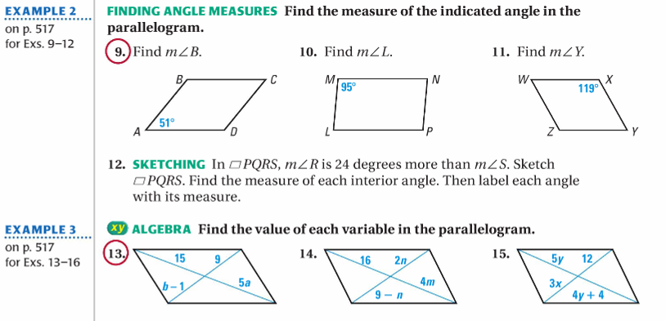
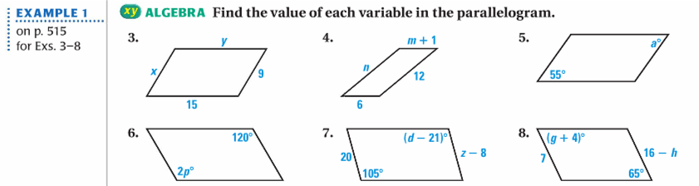
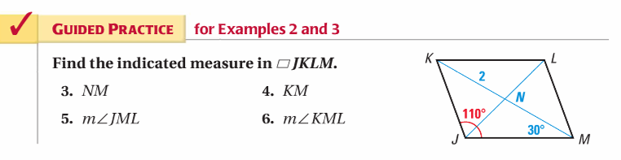

Lesson 2 Homework  BACK PAGE | LT 6.2, 6.3 | Guided Practice #3-6 (FRONT PAGE)  3-13 odd, 14, 34 (FRONT PAGE)  2-6, 8, 15, 17, 19, 21 (BACK PAGE)
